Data Engineering RoadMap Project 1
Date: Oct 26 2025
Written By: Tejaswi D

Table of Contents
Introduction 4
Session 1 4
1.1 Azure Data Engineering Role 4
1.2 What is Azure 4
1.3 Different kinds of Services 5
Infrastructure as a service (IAAS) 5
Platform as a service (PAAS) 5
Software as a service (SaaS) 5
1.4 Why Do we need cloud services 6
Key reasons for using a cloud provider 7
Disadvantages of cloud computing 7
1.5 Cloud Computing 8
Physical Architecture 8
Logical Architecture 9
Session 2 10
2.1 Multi-Cloud Architecture 10
2.2 Public Cloud vs. Private Cloud 11
2.3 Storage Accounts 12
2.4 Redundancy and Replication of Data in Azure 13
Session 3 14
Types of Storage Accounts 14
Querying Structured Data 14
Access Tiers 15
Azure Storage Account Creation 15
What is Soft delete feature 18
References 19

Introduction
This document is created to document and specify the information shared in the initial 3 sessions of Data Engineering course which is on going currently. The sessions started on Oct 17th and below are the detailed descriptions of what has been discussed.

Session 1
Topics discussed during the first session:

1.1 Azure Data Engineering Role
Data engineers specialize in building and optimizing systems that make data accessible for analytics and operational workflows. Their core responsibilities include but not limited to Building and Maintaining Data Pipelines, Collaboration Across Teams, Ensuring Data Quality and Availability.
In the real world, there’s a lot more than just designing big new systems, although building new data pipelines is certainly part of the job! As new data becomes available, you’ll need to ingest the data somehow, store it in some sort of distributed data store, and impose some sort of schema on it so it can be queried.
Troubleshooting existing systems is a big part of the job. Whenever you are dealing with large, distributed systems and messy data, there’s a lot of potential for things to go wrong. Perhaps data feed has gone down or become corrupt for some reason. Perhaps you’ve hit resource limits somewhere, or you’ve hit some sort of processing bottleneck you hadn’t encountered in the past. Perhaps there is a huge surge of data that you don’t have capacity for, or perhaps something happened that drove up your cloud computing costs that requires rapid optimization of the systems you have. Having deep experience and education equips you with the knowledge to resolve such problems quickly, and the certifications for data engineering often focus on your ability to diagnose these sorts of issues.

1.2 What is Azure
Azure is one of the leading cloud computing platforms in the market from MICROSOFT which provides a wide range of over 200 services, including computing, networking, storage, analytics, and artificial intelligence.

1.3 Different kinds of Services

Infrastructure as a service (IAAS)
It is the most flexible category of cloud services, as it provides you with the maximum amount of control for your cloud resources. In an IaaS model, the cloud provider is responsible for maintaining the hardware, network connectivity (to the internet), and physical security. You’re responsible for everything else: operating system installation, configuration, and maintenance; network configuration; database and storage configuration; and so on. With IaaS, you’re essentially renting the hardware in a cloud datacenter, but what you do with that hardware is up to you.
Usage:
Lift-and-shift migration: You’re setting up cloud resources similar to your on-prem datacenter, and then simply moving the things running on-prem to running on the IaaS infrastructure.
Testing and development: You have established configurations for development and test environments that you need to rapidly replicate.

Platform as a service (PAAS)
It is a middle ground between renting space in a datacenter (infrastructure as a service) and paying for a complete and deployed solution (software as a service). In a PaaS environment, the cloud provider maintains the physical infrastructure, physical security, and connection to the internet. They also maintain operating systems, middleware, development tools, and business intelligence services that make up a cloud solution. In a PaaS scenario, you don't have to worry about the licensing or patching for operating systems and databases.
PaaS is well suited to provide a complete development environment without the fear of maintaining all the development infrastructure.
Usage:
- Development framework: PaaS provides a framework that developers can build upon to develop or customize cloud-based applications.
- Analytics or business intelligence:

Software as a service (SaaS)
It is the most complete cloud service model from a product perspective. With SaaS, you’re essentially renting or using a fully developed application. Email, financial software, messaging applications, and connectivity software are all common examples of a SaaS implementation.
While the SaaS model may be the least flexible, it’s also the easiest to get up and running. It requires the least amount of technical knowledge or expertise to fully employ.
Usage:
- Email and messaging.
- Business productivity applications.
- Finance and expense tracking.
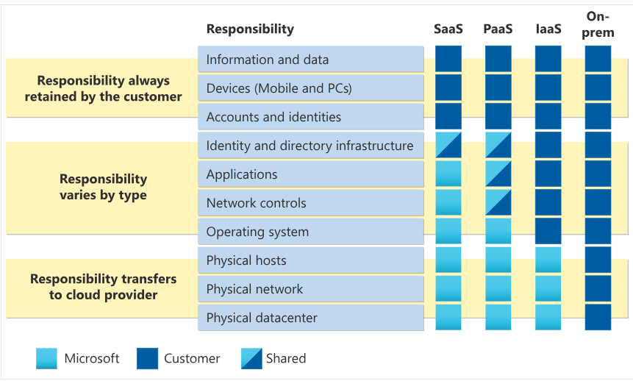

1.4 Why Do we need cloud services
We need a cloud provider to access on-demand computing resources like storage, networking, and processing power over the internet, eliminating the need to invest in and manage our own physical hardware. This approach offers significant benefits, including cost savings through a pay-as-you-go model, scalability to meet fluctuating demands, improved business agility, and enhanced business continuity and disaster recovery through built-in redundancy and backup. Cloud providers also handle infrastructure maintenance, security updates, and compliance, allowing businesses to focus on core activities.

Key reasons for using a cloud provider
- Cost savings: We will be allocated free services to some extent, and we will be extended the same as needed. Instead of making large upfront investments in hardware and infrastructure, you can pay for the resources you use, which are often more cost-effective, especially for businesses with variable needs.
- Scalability and flexibility: Cloud providers offer an elastic "pool" of resources that can be quickly scaled up or down based on demand. This means you can instantly access more power for a busy period and then reduce it when not needed, avoiding the cost of idle servers.
- Reliability and disaster recovery: Cloud providers have robust, built-in redundancy and backup systems to ensure business continuity and minimize downtime in case of hardware failure, natural disasters, or other unforeseen circumstances.
- Global accessibility and collaboration: Employees can access data and applications from anywhere in the world with an internet connection, which is crucial for remote work, global teams, and business mobility.
- Availability: We will not be at risk of losing or waiting for services even during disasters by designing the optimum redundancy method for the project we are working on based on client need.
- Storage: Cloud provider will take care of the burden of procuring infrastructure, we would need to concentrate on optimizing the usage of the same to make maximum benefit with limiting the idle hours.

Disadvantages of cloud computing
We do have some limitations in cloud computing like:
- risk of vendor lock-in
- relies on an internet connection
- less control over underlying cloud infrastructure
- concerns about security risks like data privacy and online threats
- integration complexity with existing systems
- unforeseen costs and unexpected expenses

1.5 Cloud Computing
Cloud computing is the delivery of computing services—including servers, storage, databases, and software—over the internet on a pay-as-you-go basis
Most popular cloud vendors in the market currently are Azure/ AWS/ GCP. We do have other vendors like Alibaba Cloud/ Oracle/ IBM. We have 2 significant types of Architecture in Cloud as below:

Physical Architecture
It consists of data centers, which are physical buildings with servers and infrastructure, grouped into regions for logical and geographic organization.
- Regions: Think of a region as a city or a large metro area where Microsoft has built its cloud infrastructure. You select a region when you set up a service, and the region contains a cluster of data centers. This proximity allows for high-speed communication between the data centers within that region. Azure has many regions around the world, each with a set of data centers.
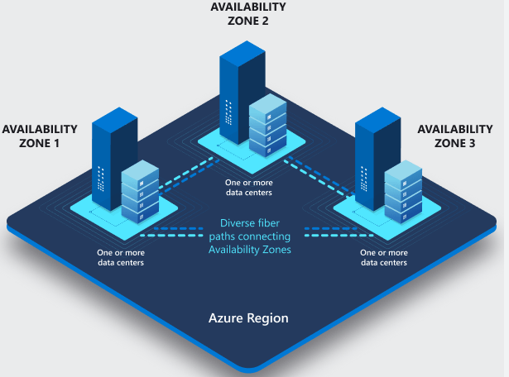
- Data Centers: These are physical buildings within a region. Microsoft has hundreds of data centers globally. In a region with availability zones, each availability zone is a separate data center. Physical separation between zones is a key factor for reliability, as it protects against local issues like power outages, cooling failures, or natural disasters affecting only one zone.
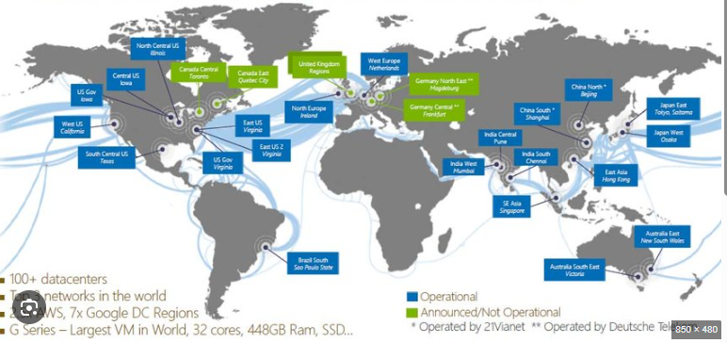
- SERVERS: Compute engines or a virtual machine for running operating systems in the cloud.
- RACKS: It is a physical or virtual space assigned to store and manage computing hardware and related resources inside a data center.

Logical Architecture
All the components involved here would be maintained on Azure portal (portal.azure.com)
- Management Group: Management groups provide a governance scope above subscriptions. When you organize subscriptions into management groups, the governance conditions that you apply cascade by inheritance to all associated subscriptions. However, all subscriptions within a single management group must trust the same Microsoft Entra tenant.
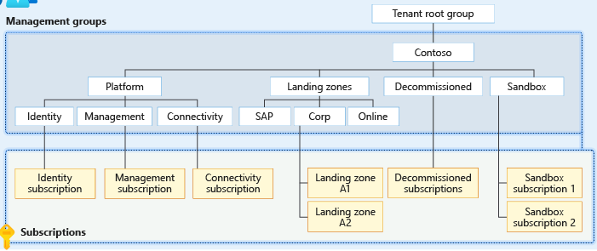
- Tenant ID: An Azure tenant ID is a unique identifier for your Microsoft Entra ID tenant, while management groups are used to organize and govern resources within that tenant, with the tenant root group contains all subscriptions
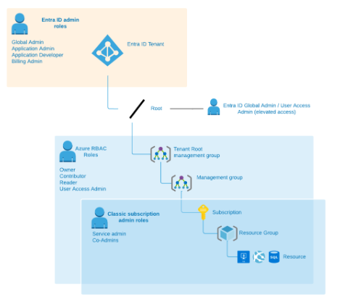
- Subscription: It is a logical container that provides a boundary for billing and management, holding related resources like virtual machines and databases.
Types of Azure subscriptions: Free(Student), Pay-As-You-Go, Visual Studio, MSDN and Enterprise Agreement.
- Resource Group: It is a logical container that holds related resources for an Azure solution, such as virtual machines, storage accounts, and web apps. The benefits of creating a resource group are Organizes related resources, Simplified management, Scope for management, metadata storage.
- Resources: A manageable item that's available through Azure. Examples of resources include virtual machines, storage accounts, web apps, databases, and virtual networks. Resource groups, subscriptions, management groups, and tags are also resources.
This is an overall Logical Architecture diagram of Azure:
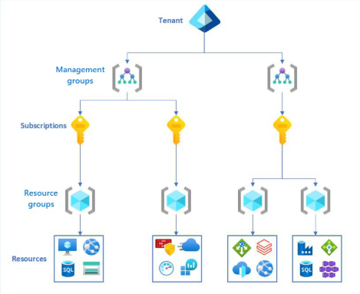

Session 2
This session mainly focused on 2 types of storage accounts – BLOB and Data Lake Gen2 after a re-cap of session-1.

2.1 Multi-Cloud Architecture
Each individual vendor involved will have their own redundancy mechanisms of data for providing low latency, high performance and DRM scenarios. There would be rare case scenarios where these options wouldn’t suffice for the situations and services might be disrupted when we choose a single vendor. In recent times multi-cloud has been preferred along with the high availability setups to avoid damaging the reputation.
A multi-cloud architecture uses cloud services from two or more different cloud providers to meet an organization's needs, rather than relying on a single vendor. This approach allows for optimizing workload by leveraging the best features of each platform.
Benefits of a multi-cloud architecture mainly involve Flexibility and optimization, Vendor lock-in avoidance, Resilience and business continuity, Compliance, Innovation etc.,
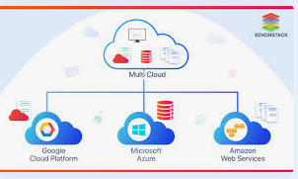

2.2 Public Cloud vs. Private Cloud
Public clouds are shared environments managed by third-party providers. Private clouds are dedicated to a single organization and offer greater control and customization.
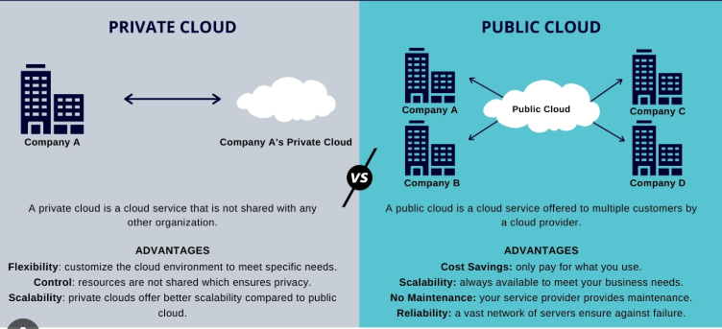

2.3 Storage Accounts
Azure Storage is a cloud-based storage solution provided by Microsoft Azure, which allows users to store and access data objects in the cloud. It offers a variety of storage options for different data types and scenarios, such as blobs, files, tables, and queues. Azure storage accounts mainly consist of 2 types of storage: BLOB or General-Purpose Storage, and Data Lake Gen2 Storage accounts. Each type supports different features and has its own pricing model. Storage accounts would be chosen based on business needs, budget allocations, Policies levied, type of workload etc.,
Just to compare the storage accounts with traditional hard drives (HDDs) offer lower cost and moderate performance, suitable for development or testing environments, whereas solid-state drives (SSDs) provides high throughput, low latency, and is best for production workloads requiring fast access times.
Aspects | BLOB(General Purpose) | Data-lake Gen2
Storage | 500 TB | 500 TB
Types of Data | unstructured data as blobs (text and binary data, images, videos, and other files) and semi structured | large volumes of data in various formats (Structured, Unstructured)
Data Security | contains security features such as encryption, role-based access control, and shared access signatures | provides strong security and compliance features, including role-based access control and encryption at rest
Accessibility | accessible via a REST API that can be accessed from anywhere | uses a distributed file system to provide parallel access to data.
Integrity | can be easily integrated with other Azure services | with Azure services for big data analytics and machine learning
Storage and Processing | designed to store and process large volumes of data in various formats | designed to store and process large volumes of data in various formats
Data Viewing | Not available | Using Serverless SQL Pool, users will be able to view data inside a file by executing SQL queries
Cost | Blob storage cost is lower. | Data Lake cost is higher due to advanced features and capabilities
Processing | Slower processing and used for backups | Faster processing and used for Analytics
Usage | store backup data for disaster recovery purposes. | storing and processing large volumes of data, fit for big data analytics
Use for Storage | storing application data such as logs, user data, and other files required by the application | store and process data for ML models, providing a scalable and secure repository for training and deployment

2.4 Redundancy and Replication of Data in Azure
Azure Storage always stores multiple copies of your data to protect it from planned and unplanned events. Examples of these events include transient hardware failures, network or power outages, and massive natural disasters. Redundancy ensures that your storage account meets its availability and durability targets even in the face of failures. The services that comprise Azure Storage are managed through a common Azure resource called a storage account.
Azure Storage offers four types of replications of your data:
- Locally redundant storage (LRS) replicates the data within your storage accounts to one or more Azure availability zones located in the primary region of your choice.
- Zone-redundant storage (ZRS) copies your data synchronously across three or more Azure availability zones in the primary region. For applications requiring high availability, Microsoft recommends using ZRS in the primary region, and replicating them to a secondary region.
- Geo-redundant storage (GRS) copies your data synchronously within one or more Azure availability zones in the primary region using LRS. It then copies your data asynchronously to the secondary region. Within the secondary region, your data is copied synchronously using LRS.
- Geo-zone-redundant storage (GZRS) copies your data synchronously across three or more Azure availability zones in the primary region using ZRS. It then copies your data asynchronously to the secondary region. Within the secondary region, your data is copied synchronously using LRS.
An overall comparison diagram of all the redundancies offered by Azure is as below:
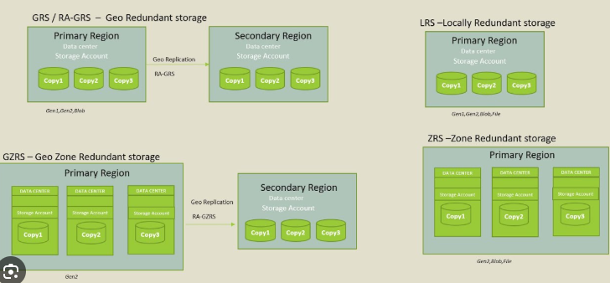

Session 3

Types of Storage Accounts
Blob Storage: Used for storing large amounts of unstructured or semi-structured data like text, images, videos, and logs.
Azure Data Lake Storage Gen2 (ADLS Gen2): Built on top of Blob Storage with added features for analytics and big data. Enable hierarchical namespace options during creation of a storage account.
An Azure storage account contains all your Azure Storage data objects: blobs, files, queues, and tables. The storage account provides a unique namespace for your Azure Storage data that is accessible from anywhere in the world over HTTP or HTTPS.
Type of storage account | Supported redundancy | Supported parameter | Hier namespace
Data lake Gen2 v2 | LRS / GRS / RA-GRS / ZRS / GZRS / RA-GZRS | StorageV2 | Yes
General-purpose v1 | LRS / GRS / RA-GRS | Storage | No

Querying Structured Data
The data stored in a storage account could be in structured, semi-structured, and unstructured formats. Structured data can be retrieved by using SQL as a coding source.
Blob Storage can contain structured data files (e.g., CSV, JSON, Parquet), which can be queried using Azure Synapse Analytics, Databricks, or ADLS query interfaces.
Azure Resource Graph supports many operators and functions, each work operates based on Kusto Query Language (KQL). Data from various Azure services using popular programming languages with their respective Azure SDKs. These include Python, JavaScript, Java, .NET (C#), and Go.

Access Tiers
Data stored in the cloud grows at an exponential pace. To manage costs for your expanding storage needs, it can be helpful to organize your data based on how frequently it will be accessed and how long it will be retained. Azure storage offers different access tiers so that you can store your blob data in the most cost-effective manner based on how it's being used. Azure Storage access tiers include:
- Hot tier - An online tier optimized for storing data that is accessed or modified frequently. The hot tier has the highest storage costs, but the lowest access costs.
- Cool tier - An online tier optimized for storing data that is infrequently accessed or modified. Data in the cool tier should be stored for a minimum of 30 days. The cool tier has lower storage costs and higher access costs compared to the hot tier.
- Cold tier - An online tier optimized for storing data that is rarely accessed or modified, but still requires fast retrieval. Data in the cold tier should be stored for a minimum of 90 days. The cold tier has lower storage costs and higher access costs compared to the cool tier.
- Archive tier - An offline tier optimized for storing data that is rarely accessed, and that has flexible latency requirements, on the order of hours. Data in the archive tier should be stored for a minimum of 180 days.

Azure Storage Account Creation
We will need to create a azure account with free subscription for 30 days. Open Azure portal using portal.azure.com. Follow the steps below to create a storage account:
- In the welcome page either search for “Storage Account” or select the same from left pane as shown below.
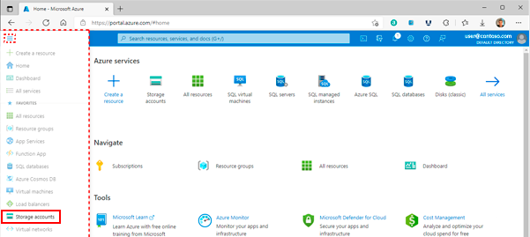
- Click on create and select the subscription into which the storage account needs to be created for.
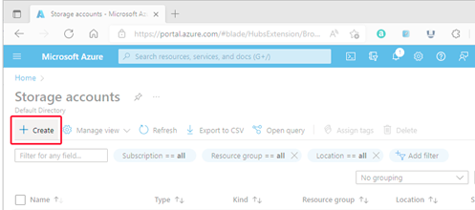
- After clicking on “Create” the below screen appears where we will need to select various options based on project need and specifications.
Subscription: The subscription under which the account needs to be created.
Resource Group: The group under which we need the account to be configured and built.
Storage A/c Name: A unique name must be between 3 and 24 characters in length and might contain numbers and lowercase letters only.
Region: Select the appropriate region for your project need and closer to usage area. Not all regions are supported by all types of storage accounts or redundancy configurations. The choice of region can have a billing impact
Performance: Select Standard performance for general-purpose v2 storage accounts (default). This type of account is recommended by Microsoft for most scenarios. Select Premium for scenarios requiring low latency.
Redundancy: Select your desired redundancy configuration. Not all redundancy options are available for all types of storage accounts in all regions.

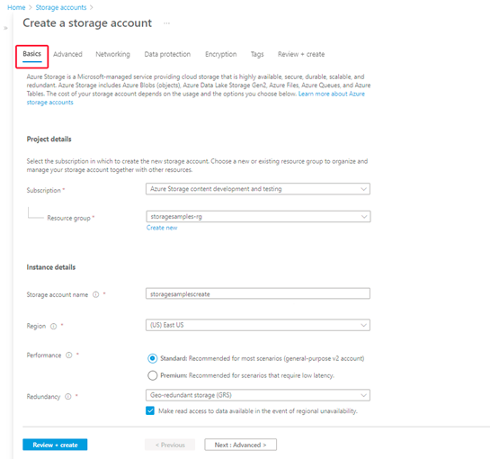
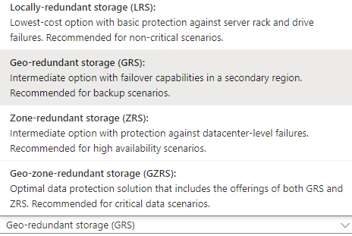

The advanced section of account creation contains other features that are non-mandatory but has significant impact on selection.
Enabling hierarchical namespace would consider the storage as Data Lake Gen-2 rather than General Purpose.
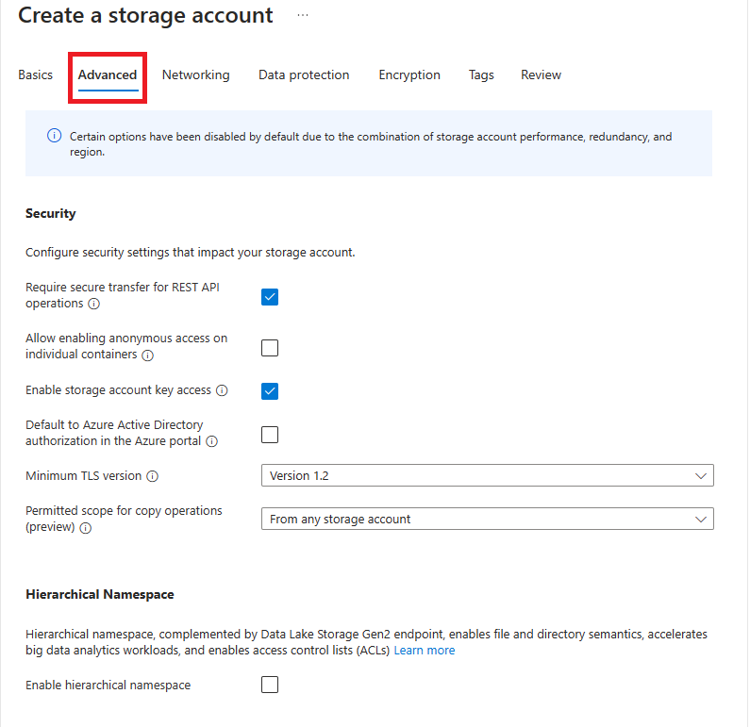

What is Soft delete feature
Azure's soft delete feature protects data from accidental or malicious deletion by retaining deleted items for a configurable period instead of permanently erasing them immediately.
- Deletion: When a user deletes an item, it is not immediately removed. Instead, it is marked as "soft-deleted" and retained in a protected, recoverable state.
- Retention period: This retention period is configurable. For example, Azure Key Vault defaults to 90 days, but can be set from 7 to 90 days. Azure Backup retains deleted backups for 14 additional days for no extra cost by default.
- Recovery: During the retention period, you can restore the soft-deleted item. For instance, in Azure Storage, you can restore a soft-deleted blob to its state at the time of deletion. In Azure Backup, you can undelete a soft-deleted VM to resume backup.
- Permanent deletion: Once the retention period expires, the object is permanently deleted and can no longer be recovered.

References
https://learn.microsoft.com/en-us/azure/storage/common/storage-redundancy

